SIMATS ENGINEERING
SAVEETHA INSTITUTE OF MEDICAL AND TECHNICAL SCIENCES
CHENNAI-602105
Department of Computer Science and Engineering
ASSESSMENT TOOL 1 – SAVEETHA COMPILER ASSESSMENT (LEVEL 1 & VIVA VOCE)
Course Code: | CSA09 | Course Title: | Programming in Java
CO Assessed: | CO1 – Manipulation (BL4) | Assessment: | AT1 – Saveetha Compiler (Level 1 & Viva)
Weightage: | 20% of CIA | Total Marks: | 100 (5 Questions × 20 Marks)
CO1 Statement: | CO1: Apply object-oriented programming principles such as classes, objects, encapsulation, data hiding, inheritance, and polymorphism to design and implement entity manipulations (BL3,BL4)
Student Name: | GK.VYSHNAVI | Reg. No.: | 192425069
Section / Batch: | AIML 2024 | Date: | 27-7-2026

Instructions to Students
Answer ALL 5 questions. Total: 100 Marks.
Questions 1–5: Write complete, syntactically correct Java programs on the Saveetha Compiler with proper indentation. Each question carries 20 Marks.
For program questions: test with at least two sample inputs; ensure output is displayed clearly. Each question carries 5 Marks.
No calculators or electronic devices permitted during the viva session.

Question Type | Description | Questions | Marks
Level 1 – Program Writing | Control Flow, classes and Object programs, Collection Framework on compiler | Q1 – Q4 | 50
GRAND TOTAL: |  |  | 100 Marks

SECTION A – LEVEL 1: PROGRAM WRITING QUESTIONS (Q1–Q5)
Q1. (Level 1 – Program Writing) [20 Marks]
QUESTION 1.NO. OF FACTORS FOR A GIVEN NUMBER
Start
Set n = 12
Set count = 0
For i = 1 to n
If n mod i = 0
count = count + 1
End If
End For
Print count
Stop

Answer / Program with output:
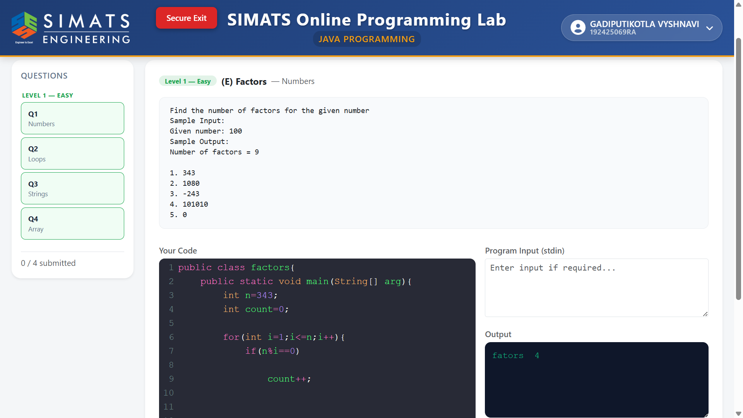
Q2. (Level 1 – Program Writing) [20 Marks]
INVERTED PYRAMID
Start
Set n = 5
For i = n to 1
Print (n - i) spaces
Print (2 × i - 1) stars
Move to next line
End For
Stop

Answer / Program with output:
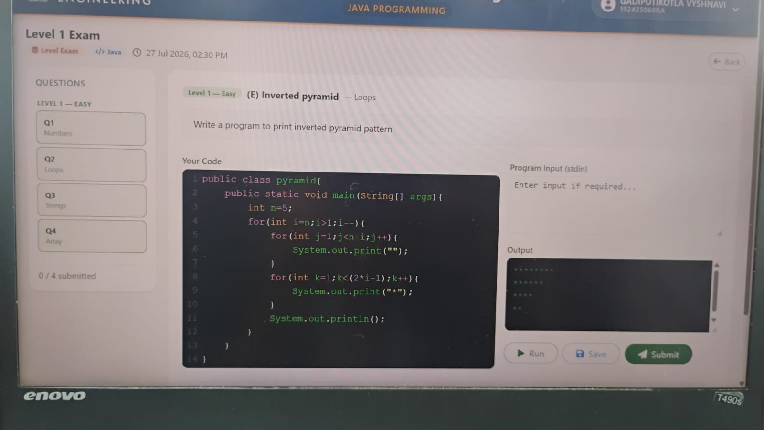

Q3. (Level 1 – Program Writing) [20 Marks]
Start
Store names in an array
Read user's choice (A/D)
Sort the array
If choice = A
Display names from first to last
Else
Display names from last to first
End If
Stop

Answer / Program with output:
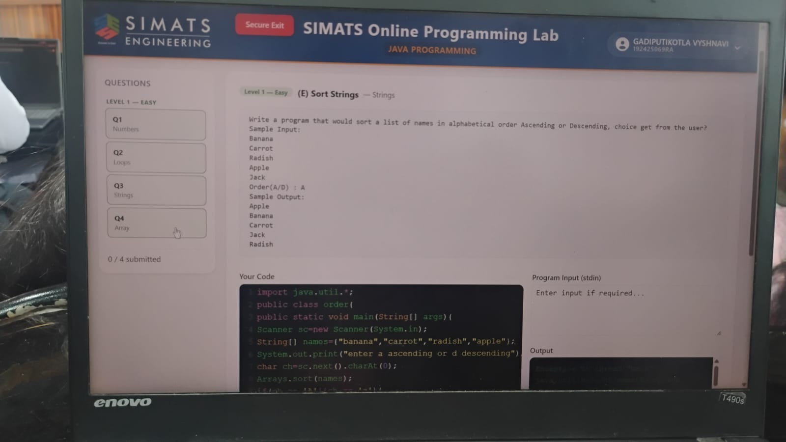

Q4. (Level 1 – Program Writing) [20 Marks]
Start
Store numbers in an array
Set count = 0
For each number in the array
Set factors = 0
For j = 1 to number
If number mod j = 0
factors = factors + 1
End If
End For
If factors > 2
count = count + 1
End If
End For
Print count
Stop

Answer / Program with output:
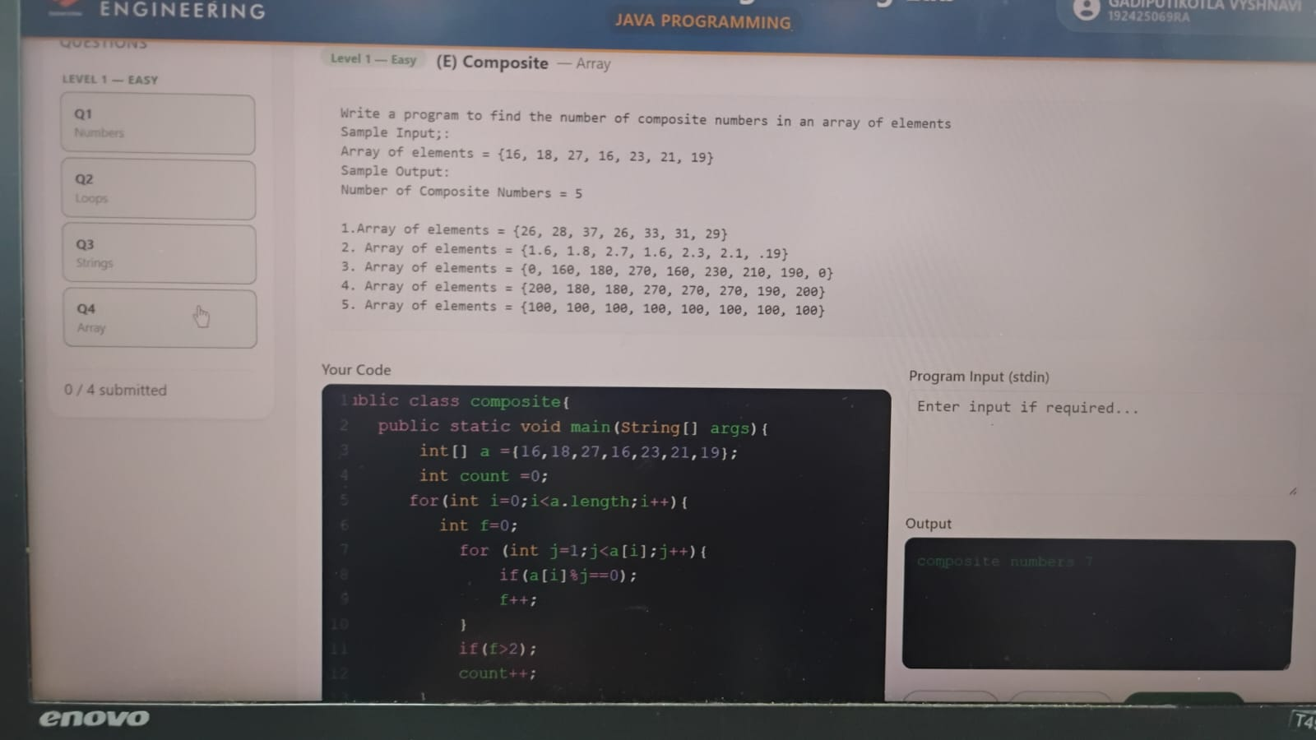

RUBRICS FOR EVALUATION
Criteria | Level 4 – Exemplary (5 Marks) | Level 3 – Proficient (3–4 Marks) | Level 2 – Developing (2 Marks) | Level 1 – Beginning (0–1 Mark)
Problem Analysis & Understanding
Logic / Algorithm Design
Python Syntax & String Operations
Output Correctness & Testing
Communication & Explanation (Viva)

Code of Conduct
I _GK.VYSHNAVI/192425069____ (Name / Reg No) certify that this submission is my original work and that I have adhered to the guidelines specified for this assessment. I understand that any violation of academic integrity rules will result in disciplinary action.
Signature of the Student: _______VYSHNAVI__________________

